# INFO253 Assignment Part 2

## Introduction

The purpose of this report is to present the full design and the scope of the website, showing each webpage and the elements that the webpage includes and the process done to have come up with the final design of the Ilam Recreation Centre website.

The business objectives for the website is to allow users to easily access general information about the centre (such as location, contact details, staffs) and to provide a payment system for selling Ilam Recreation Centre products and services easily online. The website should also handle a bulk of customer traffic to keep in house staff members at the lower end of the spectrum, so that it can handle booking of rooms and trainer and also allow users to ask questions about the centre.

The user analysis for the Ilam Recreation Centre shows that there is a strong correlation between students and being a member of the lam Recreation Centre. The design of the website has accounted for this being the case by making sure that the site has a sleek and friendly design to catch the eye of the user. Also as students may have a range of technical skill the design of the website is made to be as simple as possible, following the designs of other recreation centres websites and making sure that the site has passed the trunk test.

Trunk Test

### Is there a site ID?

### Is there a page name?

### Are there section names?

### Is there local navigation?

### Are there "you are here" indicators?

Taking account of the business objectives and the user analysis the following webpages for the Ilam Recreation Centre are designed homepage**,** login**,** schedule,feedback forum**,** website sign up, membership sign up**,** contacts, bookings**,** shopand checkout

The following pages shows the planned site map, site designs of all the planned pages of the website, including the iterations made to come up with the final design of the website. The self-evaluations of the whole project is also included for the evaluation of the website itself and for each team member that has made the design of the website. They are also references included from where ideas and graphics came from.

## Site Map

The webpage hierarchy for the Ilam Recreation Centres website is as shown below in the site map. The website navigation has been designed in a way that every webpage is accessible from any webpage giving the website an easily crawlable structure. Each page has the same navigation bar meaning there are no orphan pages and there is always a path to the homepage.

## C:\Users\Djssm\AppData\Local\Microsoft\Windows\INetCache\Content.Word\Site Hierarchy - Page 1.png

## Site Design

## Membership Page

### Version 1 Version 2

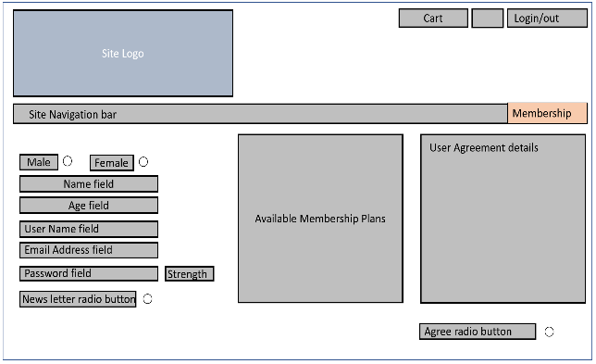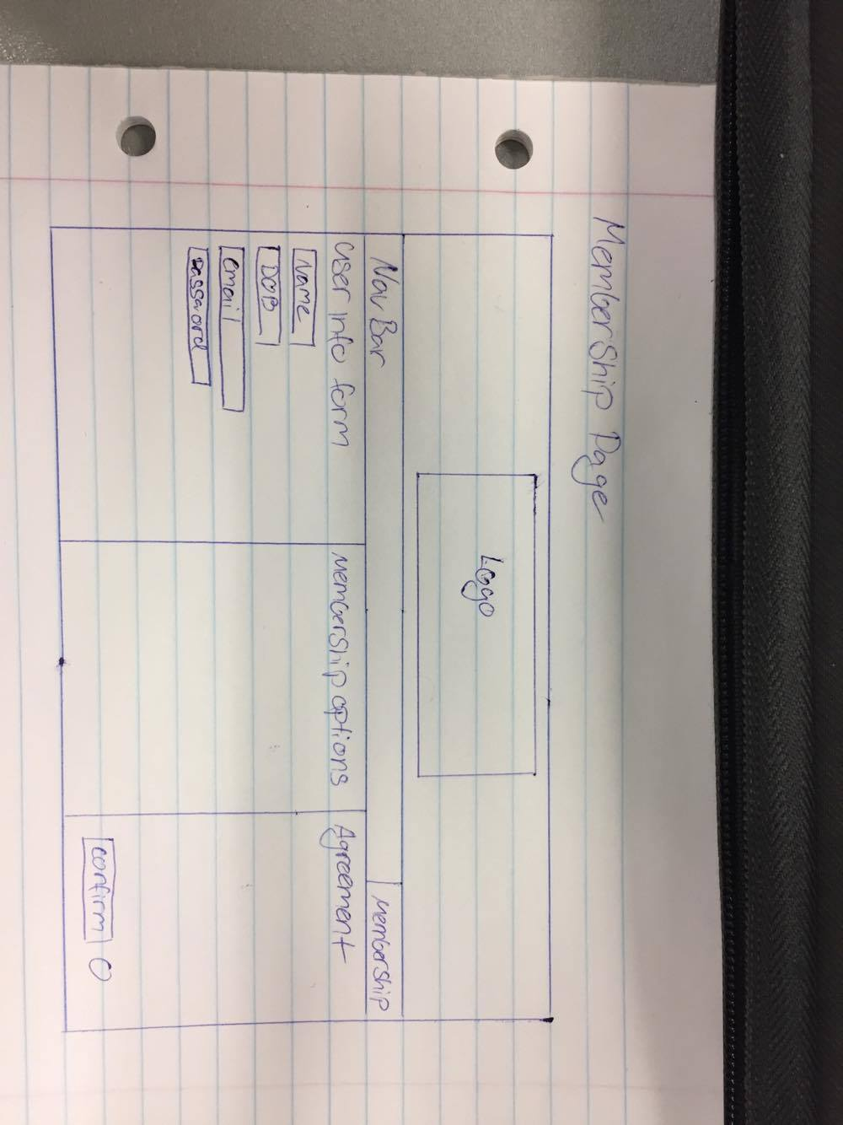

### Members Sign up Page Design Notes

After presenting the first version of the membership sign up page to the client the changes between the first two versions were minor. The repositioning of the logo image and clarification of field positioning and the included fields themselves were the only changes made, as the client thought there should be some margin between the available membership table and the user agreement field. The final version has seen much change and improvement from version 2. A decision was made to make it abundantly clear to the user what page and/or what website they’re viewing with the inclusion of a large font company name title and current page heading in the final version. Repositioning of basically all fields was implemented between versions 2 and 3 In order to clean up the presentation of the page. The client also decided that any pages with a decent amount of white space still available should include an advertisement banner of sorts to fill the gap and promote current specials on the site.

### Version 3 (Final)

## Bookings Page

### Version 1 Version 2

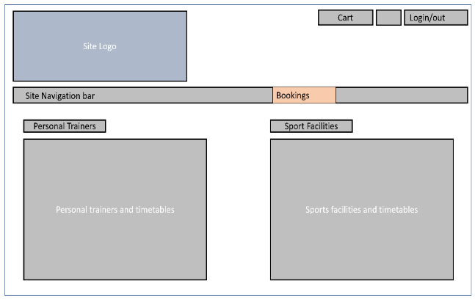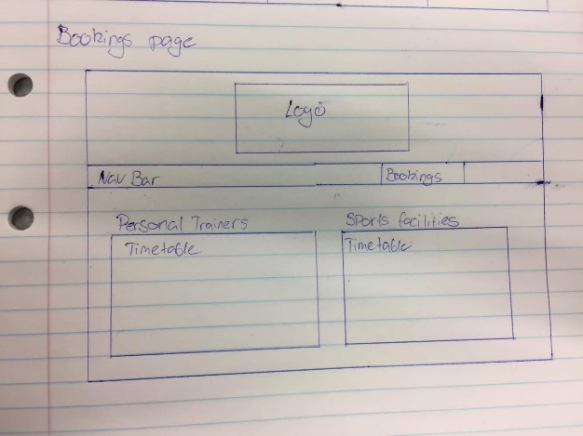

### Bookings Page Design Notes

The outline drawing of the bookings page (version 1) was presented to the client for feedback, and as the page is very bare bones with minimal content changes were very minor. The client liked the fact that the Bookings page had a very basic and easy to follow layout and so the only changes made between versions 1 and 2 were related to the positioning of the logo and the inclusion of a cart and login/logout button in the top right corner of the page. The final version of the bookings page (as seen below) was decided on after collaboration with the client and minor changes such as the reshaping and repositioning of the bookings tables were implemented. And of course, the addition of the company name title and current page heading were included to keep the page’s uniform.

### Version 3 (Final)

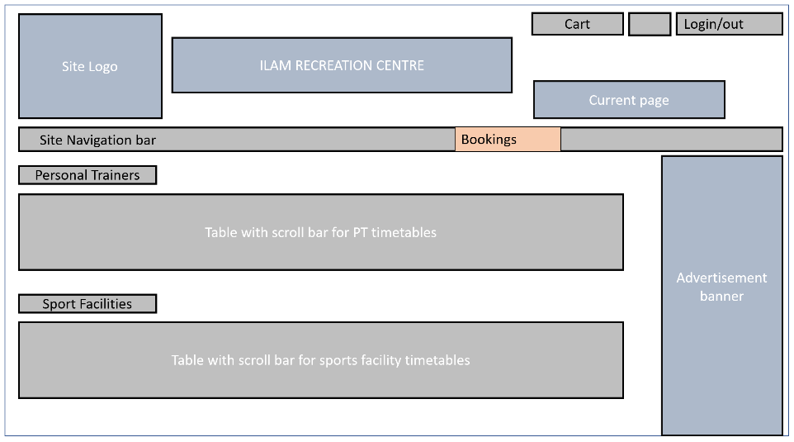

## Contacts Page

### Version 1 Version 2

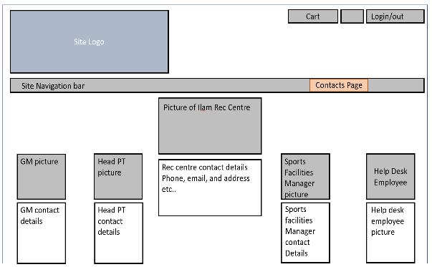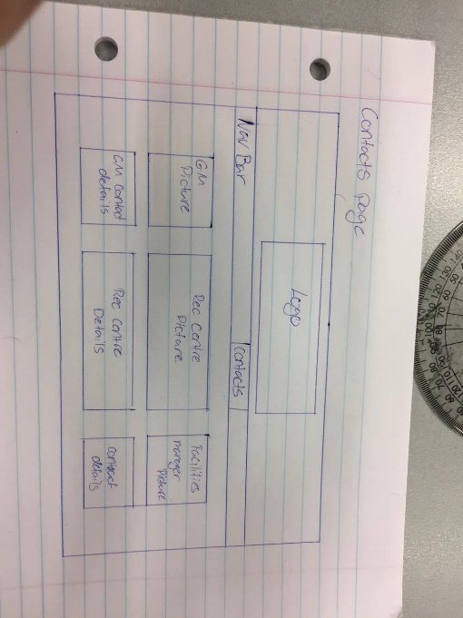

### Contacts Page Design notes

After producing the initial drawing of the basic structure of the contacts page and presenting it to our client for feedback changes were made to the contacts pages throughout 3 versions. The client was happy with the general structure of the page but preferred the logo positioned in the top left corner and wanted both login/logout and cart buttons present on each page. The client also wanted the inclusion of the head personal trainer’s contact info and potentially the inclusion of the help desk employee contact details. And so, version 2 was presented to the client and minor changes were made to the produce the final version of the contacts page as seen below. The inclusion of the both the company name title and current page heading were introduced in the final version to keep the website uniform. The client also decided that the inclusion of the help desk employee contacts details is irrelevant as users will directed to the help desk upon contacting the centre itself.

### Version 3

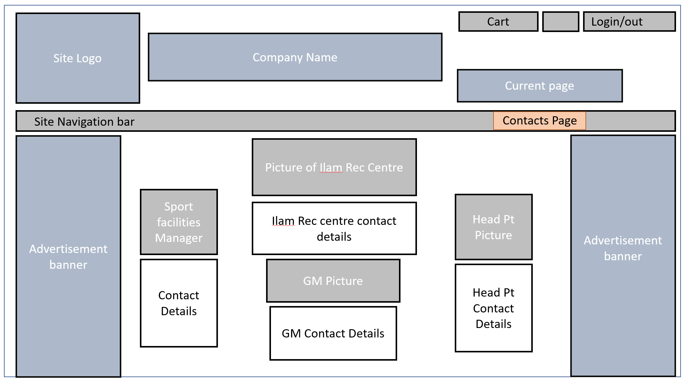

### Homepage

### Version 1 Version 2

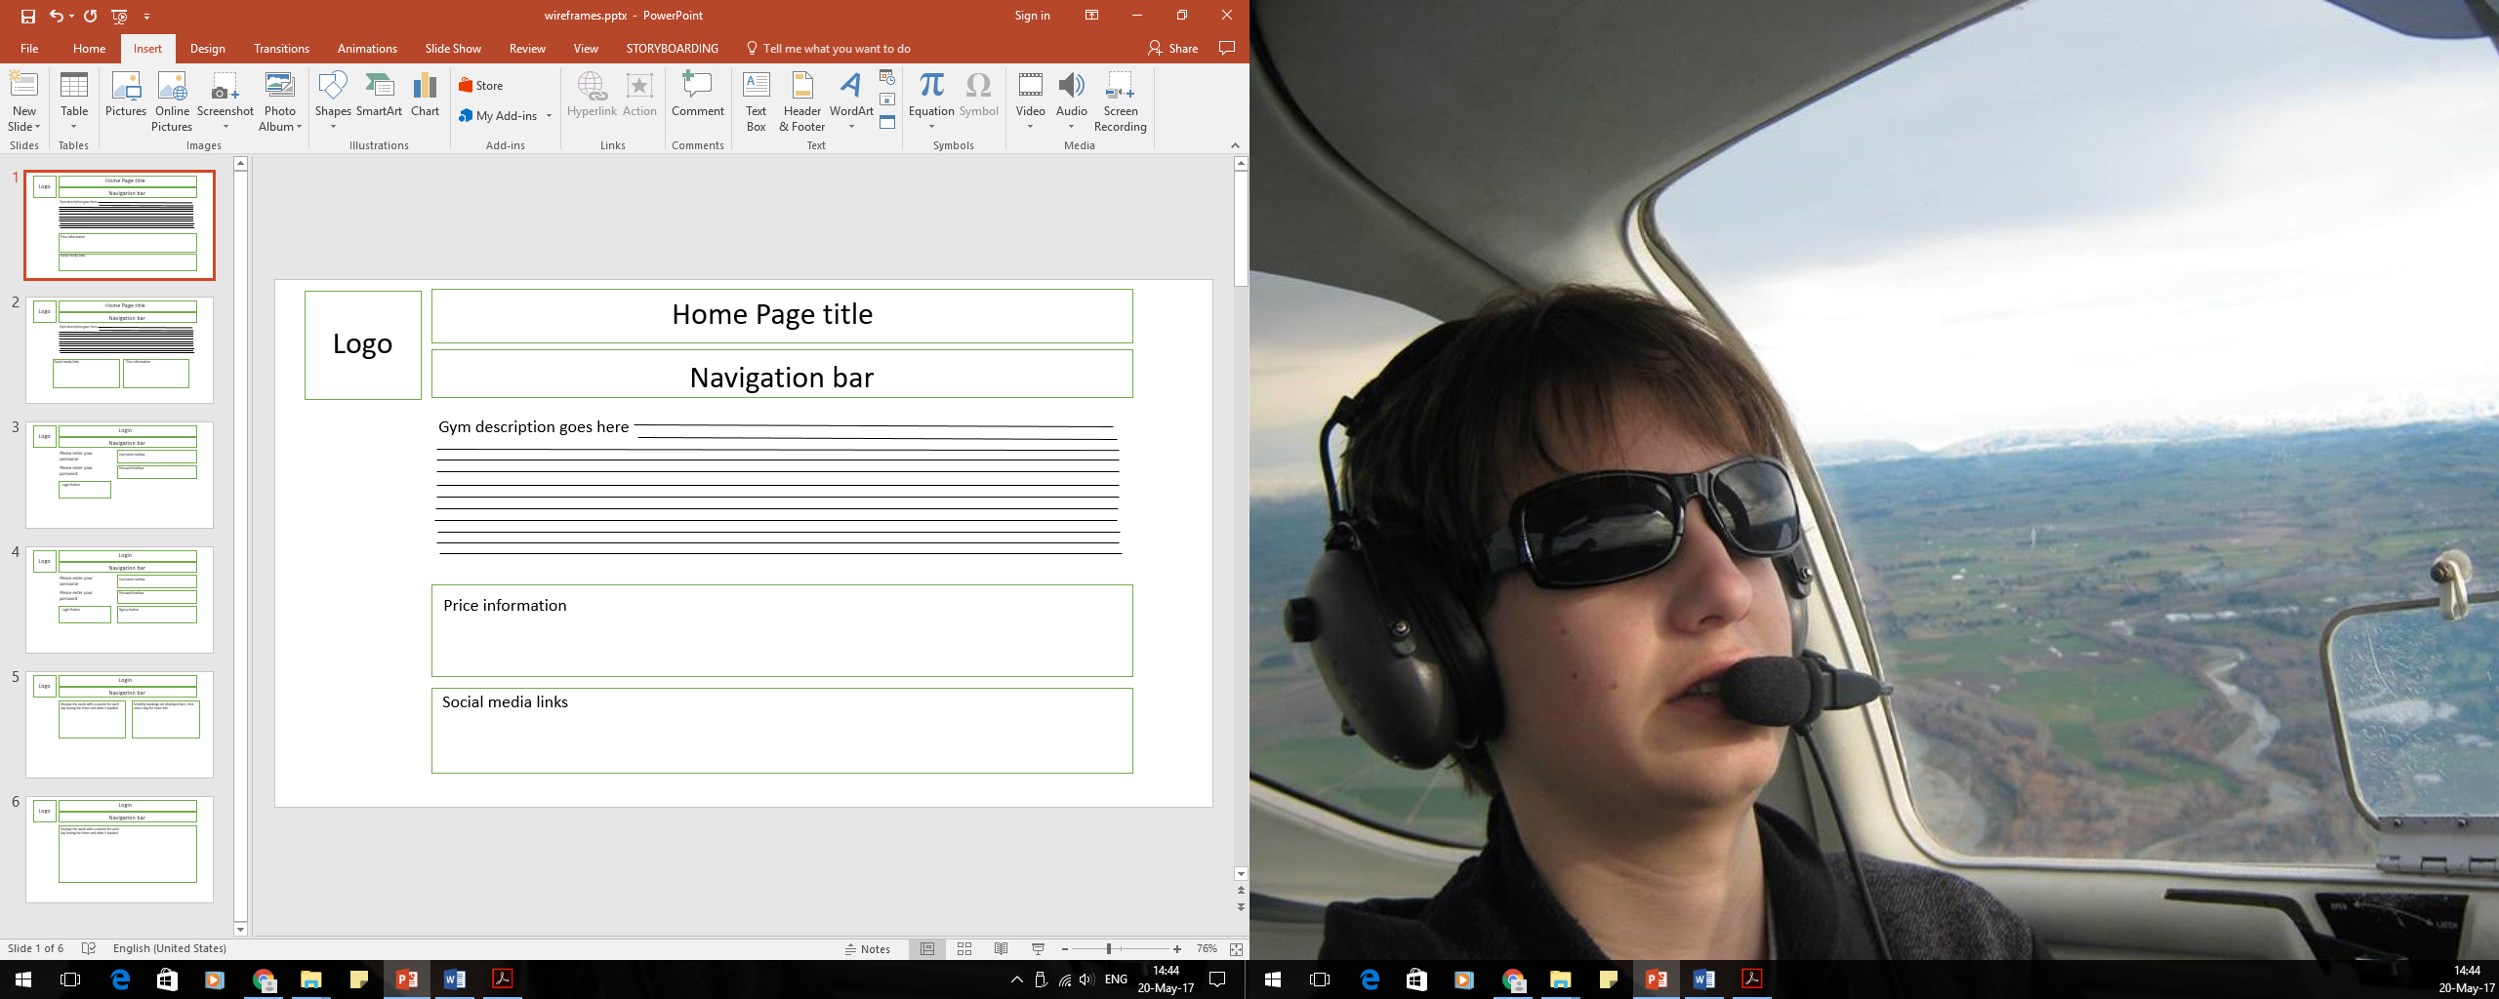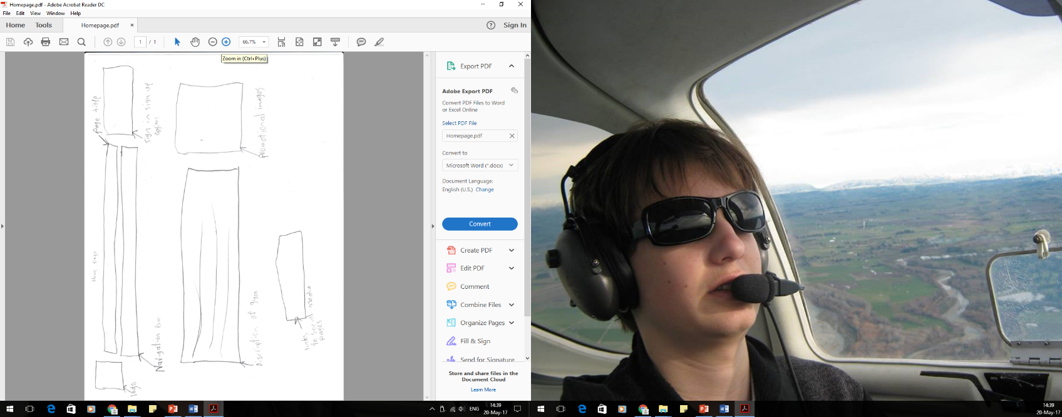

### Homepage Design Notes

I drew a rough design of the home page and showed it to our client and they didn’t like some of things I had done. They wanted the social media links next to the price table. At the time, they were unsure of having the price table and said to keep it there for now and they would get back to me. I made the changes and they didn’t like and told me to have a map showing their location. They also said they would like some images of the gym on the website.

### Version 3 (Final)

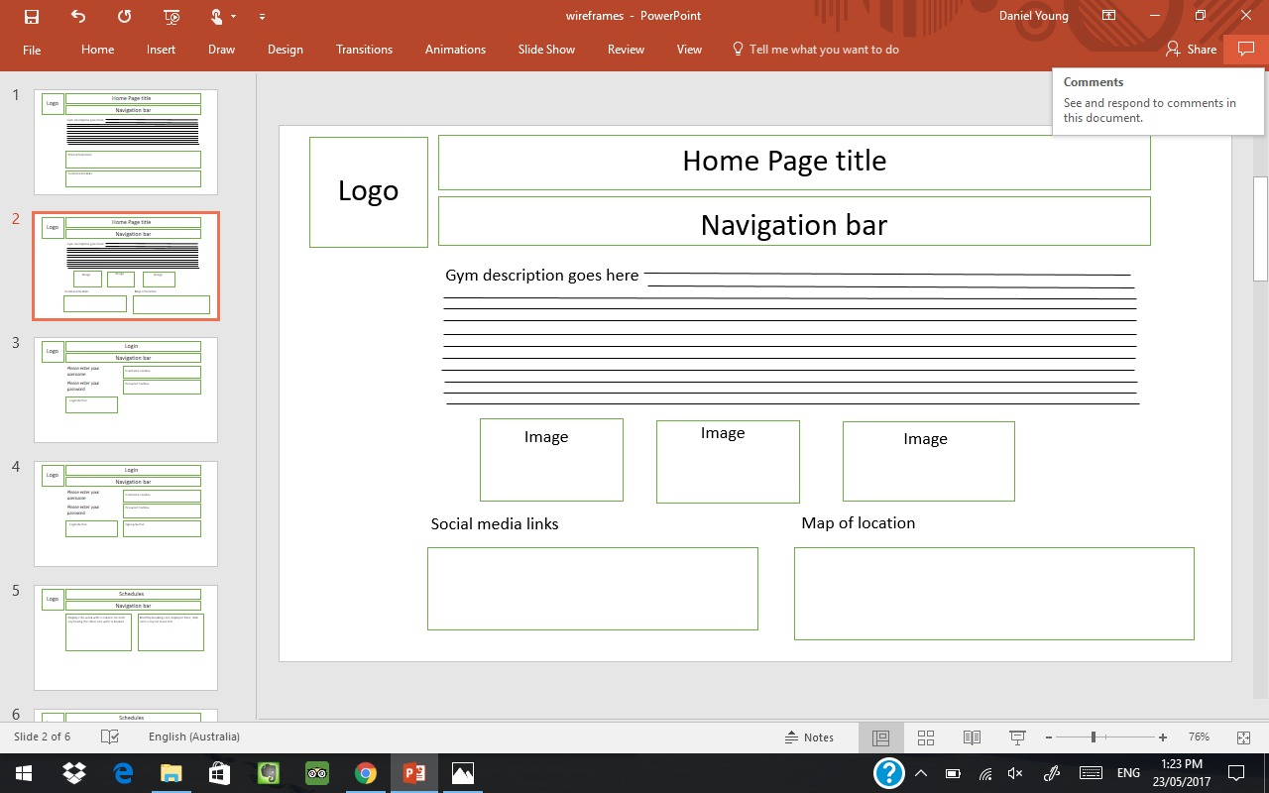

## All other planned pages

### https://lh6.googleusercontent.com/jNDKKPXEfgEoBAE0THLPgVH_pizNI-bVfdOlsj5MTBRUnIUuVSNw2hirUABzrMvqim2wzHUeTUeUf69C5FlSCStmUaltKPyKS1_1IBQu-Q9ZbvY06iKR4px-jUHgBMPpZKnOutzvX-3L_Mz7egShop Checkout

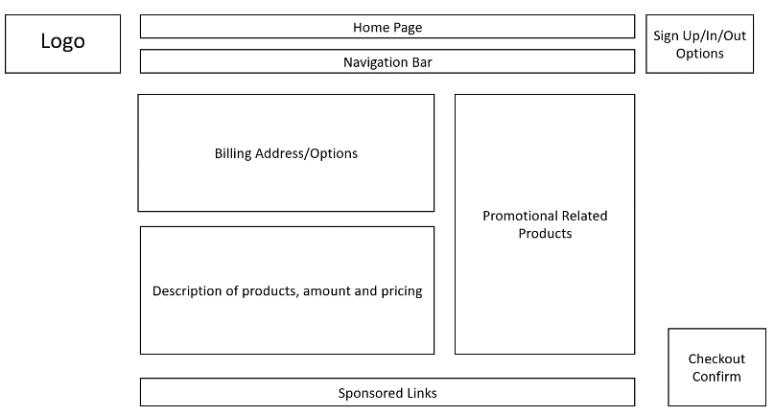

### https://lh6.googleusercontent.com/wVPbjOV91xCw7b-6Q-vFG6Ut5DhP-tctPRK4u6xH0plvSBWU_hb3hPz27WQW4Kt4xGvpZGWMLUnCCVPYwQF1QKo8MHaGbu2azqOYECm7hw84Z2hMWZ9yKGwQgA3xwd4u-WU41nBshttps://lh4.googleusercontent.com/f94VkmsR1eAwJUE8O0nORZedwQWQXtXpTV70SA8yTFYgvb5kLdLNcEw-cm3XTKZdGBNF60vc8pyhs_IE1YobV4lMcvRRpYb1c1ko-n81Z4I97DJZgAbd1vbD8j2d691UHmM4YqwpWebsite sign up Feedback

### Login Schedule

## C:\Users\Djssm\AppData\Local\Microsoft\Windows\INetCache\Content.Word\HomePage.jpgHomepage Mock up

### Home Page Mock up Design Notes

After presenting the client with various versions of what the homepage will consist of, the final version settled on (as seen above) was then used as the template for the home page mock up. The client was adamant that the inclusion of the company name title and current page heading be present in the header section for every page. Information such as a map picture of the (hypothetical) centre location and all relevant social media links were extra features added to the homepage final wireframe at request of the client. The inclusion of the social platforms essentially allows free marketing for Ilam Rec Centre as they actively post deals and specials on their social media accounts. A welcome statement describing various aspects and features offered by the rec centre was included as a means of giving users a welcome and general feel for what’s offered by the centre. Images of some of the facilities were also included as a preview of the equipment available for use at the centre.

### Explanation of Navigation structure

Current page indicator

Centre Name boldly presented



Search box

Navigation Bar

Each webpage has the following heading section structure (as seen above), in order to keep webpages uniform and allow the access of all relevant content from any page. With the use of the current page indicator the user is always made aware of their location on the site. And having the same navigation bar on each page means the user always has a route to the home page and/or any other page they wish to visit, this also allows for crawlable content so the site is easy for bots to crawl and index. A search box is also offered as a final means of finding relevant content, if the navigation proves unclear to a user they also have access to a search box to help guide them.

### Usability Evaluation of Website

All pages have been produced with properties such as accessibility, readability and navigability in mind, and as a result the relevant content provided by each page is presented in a clear manner with subheadings and sub sectioning. Take for example the bookings page, the use of subheadings for personal trainers and court bookings and clear separation of both timetables prevents any confusion for customers when booking. The website structure is accessible to anyone with internet connectivity and is built minimalistically in terms of graphics and animation to ensure strong performance regardless of user bandwidth and or hardware. Fonts and contrast of text colours have been implanted to ensure readability of textual content, hence a bold font for the name of the company is presented to the user on every page. And the navigation bar text is presented in white with a grey background in order to stand out and be easily readable.

In accordance with the recommended testing suggested by Steven Krug, the home page was presented to various friends and family members as a means of random user testing. Each of the test users were asked a series of questions:

* What is the name of the site?
* What page are you currently on?
* What services do you think are offered by this website?
* Can you perform task x/y/z?

Tasks ranged from “explain how you would make a booking on this website”, to “find the address of the centre”. Of the 8 test users, all were able to name the site and current page, 5/8 where able to name at least two of four specific services offered by the site. And finally, 6/8 where able to give an acceptable explanation of how to perform their given task.

Given that the only page we had for our test environment was the homepage and wire frames, the results, both relieving and inciteful were obviously not as comprehensive as if we were to have a test build of the whole website. As the most common reason users were un-able to establish a relevant answer for any of the questions above was due to not reading or paying attention to the welcome statement or other information provided by the home page. This suggests that overall the navigation functions as intended and is of a good standard, but perhaps improvements such as making any written statements on the webpage of a bolder more eye-catching font to ensure relevant information is not overlooked.

Overall this very early build of the homepage accompanied with the wireframes of all planned pages, based on the results of user testing presents a readable, accessible and navigable website structure.

### Self-Assessment

#### Daniel Smith

Over the course of this group project the importance of planning and communication has become increasingly apparent. During part one of the project our team followed a decent workload planning structure in which we outlined tasks to be completed based on priority and tackled each section of the project in a series of one week sprints, similar to a scrum structure. I found this to work well and required tasks were more often than not completed on time. But when came to the 2nd phase of the project the standards of our planning and work structure dropped which for me personally made part 2 much more stressful. Although I feel the standard of work presented in part 2 has been decent, had we followed through with the standards of planning and workload structure in part 1 the second part of the assignment could have been completed with less stress and hassle. If I was to start this project again I would like to ensure that planning and workload structure be implemented sufficiently throughout the entire duration of the assignment.

As far as modifications and changes made in part 2 to the original plan, for the most part the team decided to work with the initial plan from part 1. All webpages presented in the second part of the assignment were designed with the original user profiles and use cases in mind. In saying that, one change that was made was the decision to include the products page as a subpage of the shop webpage, which was introduced as a means of displaying the items available through the store.

In regards to improvements that could be made to the website, personally I think a more clean and attractive aesthetic is one improvement that the website could benefit from. Although taking into account time and experience limitations for this assignment I think what has been presented is sufficient, in a real-world scenario I would expect a more attractive build. Other than the aesthetic I think in terms usability the website provides, as in my opinion both the presentation of content and the navigation of the content is clear and easy to understand through the simplicity of the navigation bar and the current page indicators.

#### Daniel Young

I have learnt more about what goes into website designed and how important communication is especially working in a team. I learnt what it would be like in the real world working on a project. If I had to do this differently I would say I would have a group leader and have met more times a week. I would have given more time and effort into the tasks and probably communicated with my team better. In my eyes the strengths of the website are the design and iterations we put in, the consistency in the navigation bar. Weakness would be that it’s each page is designed and made by different members, i.e. one person did one lot of pages and one person did another etc. I would probably have two people at least on each page to keep everything more consistent and so you aren’t relying one person. A feature that could be added to the website could be a video or something on the home page just describe the gym a bit more.

#### Alexis Sy

Specificity to the design aspects and the main site design and features is what I would have liked to improve on if the project was started over again, and also having a clear idea on what the client and users of the website would like, but also communicating more clearly with the other team members on how to implement these aspects in the design of the website. By doing better in these aspects it would likely lessen the amount of different design iterations done on the website and therefore the design of the overall website would be more cohesive.

For my website page designs I started with a portrait orientation of what the website would look like, instead of landscape orientation. Having better communication with team members would have prevented this.

Strengths of sign-up page

* Very simple, user friendly design that has the basics of what the users need to be a member. It is also easy to follow for users, which would lessen the probability of users making errors in the sign-up form.

Weakness of sign-up page

* The sign-up page could probably have more error checking features, like making a user check the information they have typed before continuing.

Improvements of the sign-up page

* There could be a link on the side for the signing up for membership, in case the user actually meant to sign up for a membership for the Ilam Recreation Centre and not the site itself. As users may confuse the two different sign ups.

Strengths of the forum page

* It is easy to post a question on the forum for the users of the website to see, which is probably easier for the users of the site to do, instead of needing to find contact information before asking a question for the Ilam Recreation Centre.

Weakness of forum page

* The forum page could have some trouble when there are a lot of questions posted as it may be hard to find a specific question, and therefore users may post similar questions without realizing that it has already been asked and answered on a different page, leading to more pages created on the site that is unnecessary.

Improvements of the forum page

* A subsection for different forum topics could be made, as it would make it easier for users to search for topics and see if the question they have asked has already been answered before posting about a topic.

#### Danial Azlan

What I’ve learnt was what are the basics of website design and how intricate it is also learned that it is vital in any team to have cooperation and good communication between team members. Working on this project has shed some light on how the real-world work would be. If I were to do something differently for this project group, I would have better time management between my projects as I was swamped with them. I would also have communicated better and more effectively with my team to ensure a smooth flow of the project. In my opinion, the strengths of both the website designs were that it was tidy and free from clutter. The cohesiveness of both websites in terms of structure and design were good/clean. The weaknesses of the website design it that it is quite simple, unattractive and stale. A more creative and interactive experience for the customers could be redesigned to improve customer satisfaction. The improvements that I would have recommended is that the cohesiveness with the other websites could have been better, as different group members have different designs and individual preferences for their websites. The content of all the websites were presented in a clean and organised manner, as the navigation bars were easy to find and uses throughout all the websites.

## References

### Homepage Images:

Personal Trainer:

<https://lh3.googleusercontent.com/tSnr4VHrO3pj2ji2rT3nh_yOgy51odE8hqb1OMPe95ytKypkAsrwb0FMeLaliN4hUMQIXQ=s125>

Basketball Court:

<https://lh3.googleusercontent.com/tZGsPkaK3pRBA-ROlSXrrw2lePo2amap3Xo7G94iQCw52CZSX-HnhCPKY3Bgcq48EqJ2io0=s128>

Weights room:

<https://lh3.googleusercontent.com/YM9ksDxehZdtzEY29_PAOL7aIFJobwm9RpJB7-AOlcVtWDmOfgdJYiC87h0dW5FgI2PN=s127>

Logo:

<https://lh3.googleusercontent.com/ga5jHUXsD7Kot8gTjKuTFwaW3RSTBjVlwXitJyJq_km85WZ0Z41lSJpF8NWJe1njan1ZdA=s121>

### Website usability references

<https://www.nngroup.com/articles/testing-content-websites/>

<http://mashable.com/2011/09/30/website-usability-tools/#Bk.bHGkA9OqS>

Testing usability by Steve Krug